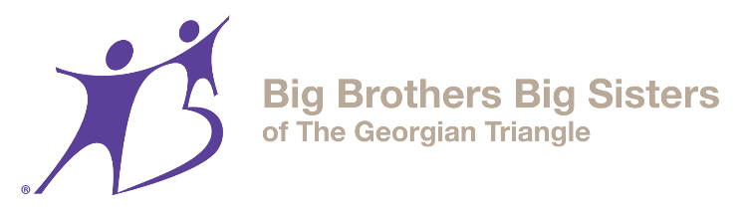
Job Postings
Logistics Lead / Registration Event Lead / Media Lead
7 Month Contract
Are you an energetic goal driven person who loves to be part of something new? Would you like to be part of changing the way funds are raised at a non-profit?
Big Brothers Big Sisters connects great role models with kids who need something more. We provide programs and events for those matched up or waiting for big brothers or big sisters. Big Change 50/50 is a new lottery that is the first of its kind in Ontario and is growing to provide the funding to support the mentorship programs of our increasing number of “littles” each year.
We are hiring 3 staff for 7 month contracts to launch our new lottery. These 3 leads will gain significant skills in the areas of social media, event planning, presentations, and logistics planning while they help to adapt the lottery process to Ontario lottery rules and demographic. They will also create systems and our lottery manual that allow volunteers to carry on specific lottery tasks to continue the lottery. By the end of the Launch, it is expected that the 3 leads will build a logistics manual that will help volunteers continue tasks to continue the weekly lottery as well as recruit 10 lottery volunteers. These staff will report to the Executive Director.

Do you qualify for the grant funding?
- On EI or was on it in the last 5 years and unemployed or underemployed
Wage: EI stipend topped up to $14/Hour
35 hours a week
Posting closing November 2nd at midnight
Qualifications:
- Pass a clear Criminal Reference Check
- Be over 18 Years old
- Hold a high school diploma
- Analytical skills
- Outgoing
- Great at promotions
- Work independently and as part of a team
- Great Coordination skills
- Community awareness
- Networking and marketing skills
- Great oral and written communication skills
- Graphic and marketing skills
- Strong computer skills
- Sales skills
- Social media skills

Logistics Lead
- Will develop the process, create the manual for:
- Create checklists for the manual and report writing
- Create systems and our lottery manual that allow volunteers to do specific lottery tasks to continue the lottery.
  - Volunteer recruitment to register lottery participants, contact new players, organize tickets, manage draw logistics, create a system for coordinating volunteer deliveries

Registration Event Lead
- Create a manual and templates that allow for planning and booking volunteers and staff for registration events, service club presentations, and community events where the registration can happen, add venues, contacts, festivals, community events, volunteers and other charities to share kiosks. Create a system for registration at events and tracking ones that we attend.
- Create checklists for presentations and presenters.
Media Lead
- Plan media marketing templates of registration of participants and attracting lottery volunteers
- Create checklists for media and ROI kits for each volunteer team so they are equipped for each event.
- Develop weekly winner marketing template and winner celebration system.
- Create a system to share the winner with each retail location.
- Create monthly newsletter template highlighting winners and cumulative amount raised for BBBS.
- Update website with weekly winner and cumulative amount raised.
- Create a social media strategy for winners and the draw
- Plan print materials
Apply in confidence to Jennifer.Ridsdale@bigbrothersbigsisters.ca

